Sermon 6 – Mat Wilson
Praying ‘Thy kingdom Come;
Psalm 47:6-8 & Luke 9:1-2 & Acts 28:21-28

Introduction
- What does it mean to pray ‘Thy Kingdom Come’?

Last Saturday night was at my twin sisters 25 wedding celebration. Chatting to people
One person – Worked as a youth worker for Ely Diocese and she was telling me that she now has a job for the Evangelical Alliance working with Gavin Calver – Director for Mission and Chair of Spring Harvest. “He’s the best she said….”

- Well – here’s Gavin’s view on the Kingdom - watch the video – Gavin Calver

Gavin says, “when you pray ‘Thy Kingdom Come’ you give the opportunity for everything to change

Relinquish control of what is going to happen next

I come open handed to the Lord and say, ‘your kingdom come’

It’s a moment of submission

We are very good at saying
‘my terms and condition / ‘my abilities’ / ‘my agenda’ / ‘my perspective’ / ‘my way’

But when we pray – ‘thy / your kingdom come’ we have a different way of thinking and acting.
We submit everything to God and say your will be done!
Jesus, take the wheel!
No, not like that! Slow down! Left! Go left! I said LEFT!
Why are you going so slow?
When did I ask you to slow down!
Where are we?
Why wouldn’t you take the express?
Stop. Get out. Let me drive.
(Gets lost)
Jesus take the whell

My prayer life .
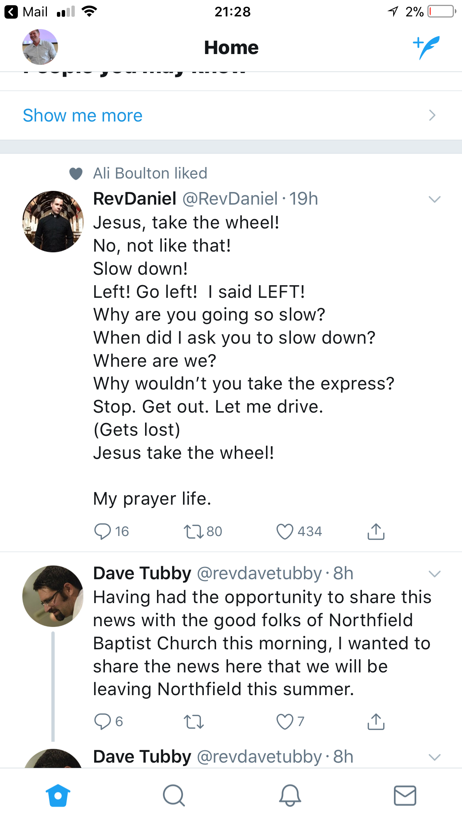

Jesus spoke about the kingdom more than any other topic.
- The word ‘kingdom’ is found fifty-five times in Matthew;
- twenty times in Mark,
- forty-six times in Luke
- and five times in John.

It is the main theme that was most on Jesus’ heart and mind
- Described as a mustard seek
- Once found it is like discovering a pearl

The kingdom is the decisive way in which God takes action in the world

The message of the Kingdom – the rule of God (the decisive action of God in the world) is what Jesus called his disciples to share.

He sent them out to tell everyone about the Kingdom and to heal the sick. Luke 9:2

There are many things we can say about the kingdom but today I just want to focus on three things that we should be open and expectant about when we pray ‘Thy Kingdom Come.

Come and…

- Renew our relationship with Jesus (stone / flowers)
All Christians to find new life in their relationship to Jesus Christ. Grow in personal faith and discipleship. Joy in times of gladness and comfort in times of sorrow. Renew their passion for Jesus.

God has taken action in our favour once and for all
A new heart I will give you and a new spirit I will put within you; I will remove from your body a heart of stone and give you a heart of flesh. Ezek 36:28

We need a new heart – Tinman – Wizard of Oz
It isn’t that we have no heart it is just that it can become cold, distant – like stone. Unmoved.
We need a heart that is warm, open and receptive to the kindness of God and the freshness of the Spirit.

Dangerous prayer – Tweet by Welby
- Quote – Justin Welby ‘not praying is a guarantee of a quiet life. It may be an unpleasant life. It may be a very tedious life. It may be a despairing life. But it will at least be a quiet life, if you like that kind of thing.’

Picture –
‘we want change’ - People put hands up for this and get excited
or
‘we want to change’ People put their heads down and hope to not be noticed

Are we open to being transformed by the work of the Holy Spirit?
What might this look like?

- The way Jesus changed his disciples was by living among his disciples
- The way our hearts our changed is through prayer – which is actually being with Jesus

Prayer is listening to the voice of the Spirit within who daily fills our hearts with love, joy, peace, patience and kindness.
Through prayer we dwell with Jesus and Jesus dwells with us.

Quote – ‘prayer is the therapy through which our hearts of stone are progressively turned into hearts of flesh because prayer is simply remaining in the presence of the lord just as flowers remain exposed to the light of the sun that sustains their life.’ ‘Say it Loud

Daily we need renewal and pray ‘thy kingdom come’
Just like flowers the moment we stop turning to the sun we start withering

Prayer
‘Lord, you know everything; you know that I love you.’ John 21:15 – Peter

‘You know Lord that indeed I will keep presuming on myself, on my love for you;
I will keep alternating between burst of enthusiasm and times of discouragement and guilt;
I will keep disowning you in one way or another…

But I now know that my hope for faithfulness lies not in me but in you and I will keep begging daily for forgiveness and for love, asking to the Father as you taught us: may your Kingdom come, take action in my favour, give me the daily bread of love and forgiveness and tenderness and hope that keeps my heart new!’

Come and help us...

- Reflect the life of Jesus to those we know and love (mirror)
All those you meet and are close to – family, friends, colleges….that they might see something of Jesus Christ in you and are drawn towards Jesus and learn of his love.

This Thursday I am going to Rome – belated 20th wedding anniversary present (it is now our 21st!) and I’ve always wanted to go.
Passage today is about the apostle Paul who arrived in Rome with the aim of sharing the good news of the Kingdom
It was a message and a movement that was met with resistance

- In Rome Paul had his own lodgings but was guarded by a soldier
- He called together the local Jewish leaders to tell them about the Messiah
- He appealed to Ceasar – Roman authority
- He shared the good news of the Kingdom – accepted by some / rejected by some

It caused one crowd to want to throw Jesus off a cliff Luke 4:29
and another want to make him king – John 6:15

Examples
- Praying for a friend

- Life given to Jesus – 2 young people

- Alison – running

- 5 people to pray for…

Come and….

- Revitalise the church we belong to (overflowing – cup overflowing)
For the church to be a place full of life and joy of Jesus Christ. To be a place that overflows with the reality of the presence of spirit of Jesus together and wherever it overflows to. In service, in love, in compassion, in working with poor.

Church from lukewarm to being alive to the Spirit

We’ve been through a tough period in the last year
Challenging times
Time of suffering together / suffering alone

But God is doing a new thing among us.

- Overflows….
- Passion for His name
- Greater confidence in who we are as the people of God
- Deeper reliance upon the Lord
- Stretch our faith, our resources, our trust
- Build bridges
- A people of hope

Prayer in to action – Shane Clairborne – getting off our knees!
https://www.youtube.com/watch?v=1ylPFl_5CYI

Illustration -
- Kyn – café

Conclusion - Psalm 24 (King)
The earth is the Lord’s, and everything in it,
the world, and all who live in it;
² for he founded it on the seas
and established it on the waters.
³ Who may ascend the mountain of the Lord?
Who may stand in his holy place?
⁴ The one who has clean hands and a pure heart,
who does not trust in an idol or swear by a false god.^{[a]}
⁵ They will receive blessing from the Lord
and savlation from God their Saviour.
⁷ Lift up your heads, you gates;
be lifted up, you ancient doors,
that the King of glory may come in.
⁸ Who is this King of glory?
The Lord strong and mighty,
the Lord mighty in battle.
⁹ Lift up your heads, you gates;
lift them up, you ancient doors,
that the King of glory may come in.
¹⁰ Who is he, this King of glory?
The Lord Almighty—
he is the King of glory.

Communion (song – Your Kingdom Come – Pete James)

Find on youtube
https://www.youtube.com/watch?v=mA2q295l9A0

Song lyrics

Made in perfect love
Innocent we walked as friends of God
Still we turned away
Traded freedom for a life enslaved

Helpless we were lost
Heaven sent the rescue plan of God
Through the love of Christ
We are found and born in to new life

We are watching, we are waiting
We are hoping, we are praying
We’re believing, let your kingdom come

Father in heaven, your name is holy
Yours, is the Kingdom, the power and the glory
God of salvation, unfold your story
Yours, is the Kingdom, the power and the glory
Amen

King of endless love
Here on earth just as heaven above
Let your will be done
Wake our hearts and let your kingdom come

We are watching, we are waiting
We are hoping, we are praying
We’re believing, let your kingdom come

Father in heaven, your name is holy
Yours, is the Kingdom, the power and the glory
God of salvation, unfold your story
Yours, is the Kingdom, the power and the glory
For ever and ever
Amen

